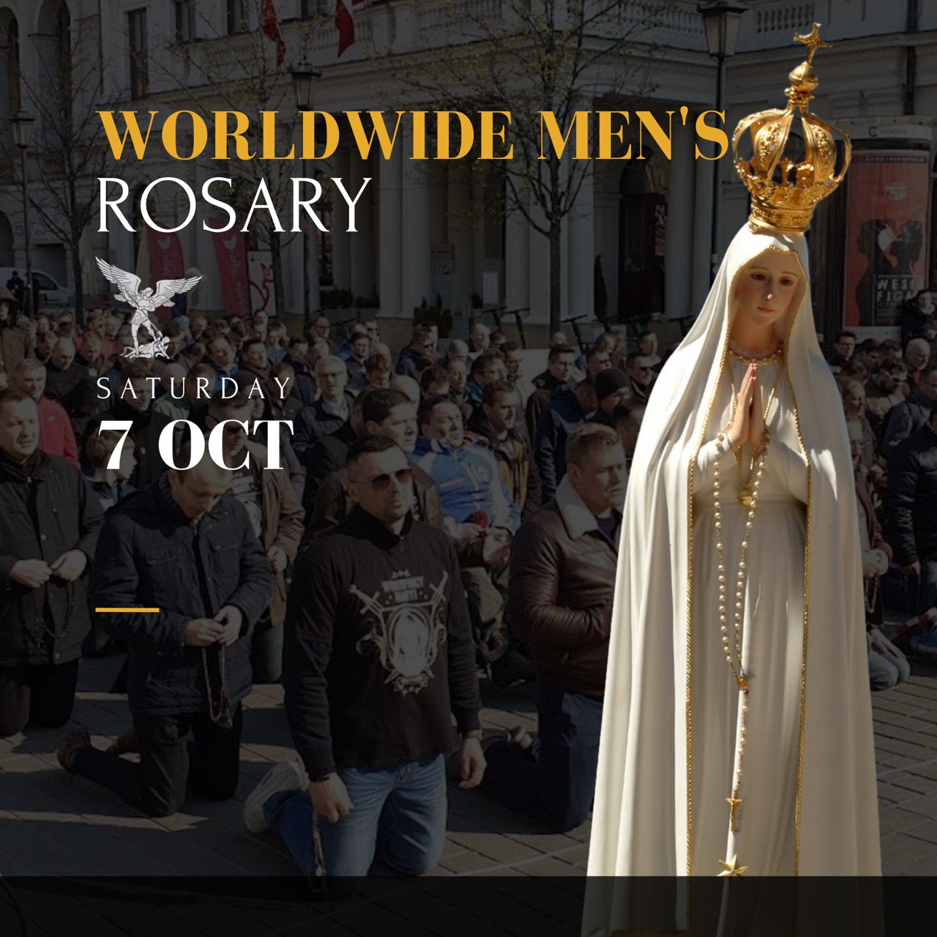
Time
Location Details
Mass & Confession Info

CITY Name
CRUSADE

